# Internet of Things

**– class discussions**

**Discussion – Student A**

1. What do you know about the Internet of Things?
2. What would life be like without the Internet?
3. What do you think is the most useful thing about the Internet?
4. What technological revolutions do you think will happen?
5. What are the bad things about devices being interconnected?
6. Is it better to order milk yourself or let a computer do it?
7. 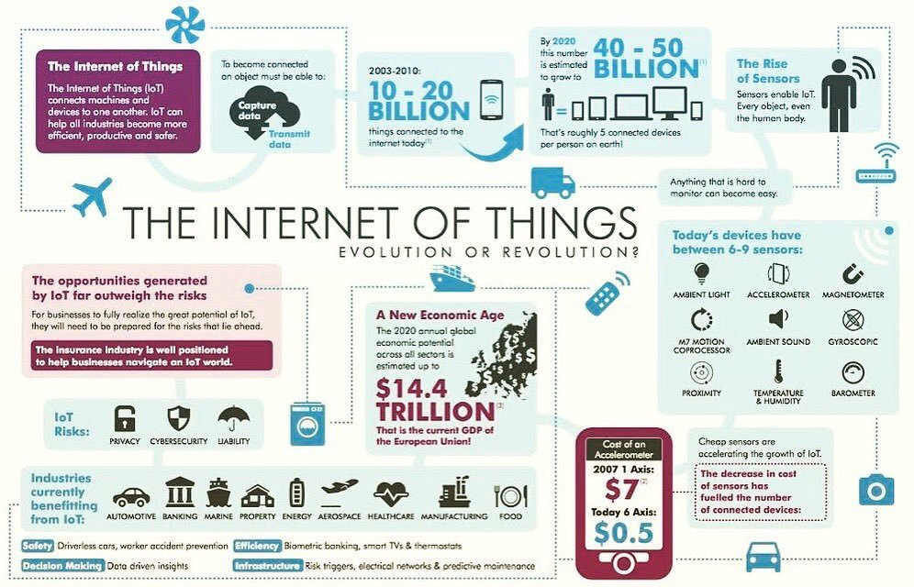Will we need workers in the future?

# Discussion –

**Student B**

1. What bad things could the Internet of Things bring?
2. How worried are you about the unforeseen?
3. What are your favourite devices and why?
4. Would you like your life to controlled by connected devices?
5. How concerned are you about privacy on the Internet?
6. What do you think of the idea of our brain being connected to the Internet?
7. What questions would you like to ask an Internet expert?